**Project title:**

Machine learning model deployment with IBM cloud Watson Studio.

**Problem statement:**

Become a wizard of predictive analytics with IBM Cloud Watson Studio. Train machine learning models to predict outcomes in real-time. Deploy the models as web services and integrate them into your applications. Unlock the magic of data-driven insights and make informed decisions like never before!

**Problem definition:**

The project involves training a machine learning model using IBM Cloud Watson Studio and deploying it as a web service. The goal is to become proficient in predictive analytics by creating a model that can predict outcomes in real-time. The project encompasses defining the predictive use case, selecting a suitable dataset, training a machine learning model, deploying the model as a web service, and integrating it into applications.

**Project Objective:**

A cloud-based predictive analytics solution has been designed using IBM Cloud Watson Studio that empowers users to train, deploy, and integrate machine learning models into their applications. The goal is to harness the power of data-driven insights, enabling users to make informed decisions in real-time and unlocking the magic of predictive analytics.

**Design Thinking Process:**

Design thinking is a human-centered approach to solving problems and creating innovative solutions. To address the problem statement of becoming a wizard of predictive analytics with IBM Cloud Watson Studio, you can follow a design thinking process with the following steps:

***Empathize*:**Understand the target users or audience who want to become wizards of predictive analytics.

***Define:***Clearly define the problem you're solving, considering the users' perspective.

***Ideate*:**Brainstorm creative solutions to address the defined problem.

***Prototype*:**Create a prototype or mockup of the cloud application that will help users become predictive analytics wizards.

***Test:***Gather feedback from potential users by allowing them to interact with the prototype.

***Implement:***Develop the cloud application based on the refined prototype.

***Deploy:***Deploy the application on a cloud platform, such as IBM Cloud, for accessibility and scalability.

***Iterate*:**Continuously gather user feedback and make improvements to the application.

**Predictive use case**

Description:

PMML is an XML based language used to represent predictive models created as the result of the predictive modeling process. It allows for predictive models to be easily shared between applications.

Key Components:

● Data Collection

● Data Preprocessing

● Model Selection

● Model Training

● Validation and Evaluation

● Fine-tuning

**Development Phase:**

**Step 1: Set Up IBM Watson Studio**

1. Create an IBM Cloud Account:

If we don't already have an IBM Cloud account, we'll need to create one. Visit the IBM Cloud website (https://cloud.ibm.com) and sign up for a free account.

1. Access IBM Watson Studio: After creating our IBM Cloud account, log in to IBM Cloud

3. Create a New Project

i. Once logged in, navigate to the IBM Watson Studio service.

ii. Create a new project within Watson Studio to organize your work. Give your project a name and, if applicable, a description.

4. Define the Project Type

5. Configure the Project:

6. Invite Collaborators

7. Data Import

**Step 2:Data Collection and Preparation:**

**Data Collection:**

• Identify Data Sources: Determine where our data will come from. It can be internal databases, external sources, or a combination of both. Identify the specific data needed to address

your predictive analytics problem.

• Data Retrieval: Obtain the data from the identified sources. Depending on the source, we may need to use SQL queries, web scraping, APIs, or other methods to retrieve the data.

• Data Import: Import the collected data into your IBM Watson Studio project. We can typically do this via the project interface or using programming languages like Python or R.

**Data Preparation:**

Explore the imported data to understand its structure. Use basic commands and tools to check the data's dimensions, data types, and an initial sample of records.Address missing data: Identify and handle missing values using techniques like imputation, removal, or interpolation.Remove duplicates: Check for and eliminate duplicate records from the dataset. Outlier detection and handling: Identify outliers and decide whether to remove, transform, or keep them based on their impact on the analysis.

**Data normalization**

If your data contains features with different scales, apply scaling techniques like Min-Max scaling or standardization.

**Data Splitting**

Split our data into training, validation, and test sets. The training set is used for model training, the validation set for model tuning, and the test set for final model evaluation.

**Data Preprocessing**

Apply any further data preprocessing steps such as standardization, dimensionality reduction, or other techniques that can improve the model's performance.

**Data Export**

Save the cleaned and pre-processed data in a format that is easy to work with for building machine learning models. Common formats include CSV, Excel, or database tables.The quality and preparation of our data play a significant role in the success of our predictive analytics project. By completing this step effectively, we ensure that your data is ready for model development and that the models can learn meaningful patterns and make accurate predictions.

**Step 3: Model Building:**

1)Select Appropriate Algorithms:

Choose machine learning algorithms that are suitable for our specific predictive analytics problem. Common choices include linear regression, decision trees, random forests, support vector machines, or neural networks.

2)Data Preparation:

Ensure our data is prepared and cleaned, as discussed in the earlier steps. This involves handling missing values, encoding categorical data, and scaling or normalizing features.

3)Split Data:

Divide our dataset into three sets: a training set, a validation set, and a test set. The training set is used to train the model, the validation set is for tuning hyperparameters, and the test set is for final model evaluation.

4)Model Training:

Train our chosen machine learning model on the training data. Watson Studio provides an integrated environment to do this using popular libraries like scikit-learn or TensorFlow.

**Step 4: Model Deployment :**

Model deployment is a critical step in our project for becoming proficient in predictive analytics with IBM Cloud Watson Studio. This step involves making your trained machine learning models accessible to applications through web services. Here's a guide on how to deploy your models:

1. Select the Model:

Choose the best-performing machine learning model that you want to deploy. This should be the model that we have thoroughly trained and evaluated.

2. Preprocessing and Transformation:

Ensure that any preprocessing steps used during model training are replicated during deployment. This ensures that incoming data to the deployed model is processed correctly.

3. Create a Deployment Space:

- In IBM Watson Studio, navigate to the model deployment section.

- Create a deployment space or project where you can manage your deployment assets.

4.Model Deployment:

- In the deployment space, select the model we want to deploy.

- Follow the prompts to deploy the model. We may be asked to specify the deployment environment and configuration settings. Watson Studio makes this process user-friendly.

5. API Endpoint:

Once deployed, our model will have a unique API endpoint that can be used to make predictions. This endpoint is typically a URL that accepts input data and returns predictions.

6. Scalability and Load Balancing:

Depending on our use case, consider setting up load balancing and ensuring the deployed model can handle a scalable number of requests.

7. Security and Access Control:

Implement appropriate security measures to protect our API endpoint. Ensure that only authorized applications or users can access and use the model.

8. Documentation:

Create documentation for the API endpoint. Include details about the expected input format, response format, and any required authentication or API keys.

9. Testing:

Before integrating the model into applications, test the API endpoint to ensure it's functioning as expected. Use sample data to validate that it returns accurate predictions. Model deployment in IBM Cloud Watson Studio is designed to be user-friendly and efficient. By following these steps, you ensure that your trained models are accessible and capable of making real time predictions, which is a fundamental part of unlocking data driven insights for informed decision-making.

**Step 5: Integration with Applications:**

In this step, we'll seamlessly incorporate the deployed machine learning models into your existing or new software applications, such as web apps, mobile apps, or backend services. Integration enables these applications to utilize the predictive power of your models in real-time, which, in turn, empowers data-driven decision-making.

1. API Integration:

Our deployed models typically expose an API endpoint that applications can communicate with. These APIs allow applications to send input data to the model and receive predictions as responses. Integration usually involves making HTTP requests to this API.

2. Data Input and Output Formats:

Ensure that our applications understand the expected input data format for the model. This might involve converting user inputs into a format suitable for the model, and then processing the model's predictions.

3. Security:

Implement security measures, including authentication and authorization, to ensure that only authorized applications can access and utilize your model's API. This helps protect sensitive data and the integrity of our predictive analytics.

4. Scalability:

Consider the scalability of your application and model integration. Ensure that our applications can handle a high volume of requests and that our deployment infrastructure can scale accordingly.

5. Error Handling:

Implement robust error-handling mechanisms in our applications to deal with scenarios where the model may fail to make predictions or encounters unexpected input data.

6. Testing:

Rigorously test the integration of the model within our applications using a variety of input data and scenarios. Verify that the predictions align with your expectations and are used appropriately.

By successfully integrating your predictive analytics models with our applications, we enable them to provide data-driven insights and real-time decision support to users. This is a pivotal step in making informed decisions, as outlined in your problem statement, and harnessing the magic of data-driven insights in a practical and actionable way.

**Step 6: Monitoring and Maintenance:**

To become proficient in predictive analytics with IBM Cloud Watson Studio, monitoring and maintenance are essential for ensuring that our predictive models consistently deliver accurate and valuable insights.

• Metric Tracking:

Use specific performance metrics relevant to our problem. For instance, if we're predicting customer churn, track metrics like accuracy, precision, recall, or F1-score to evaluate the model's performance.

• Continuous Performance Evaluation:

Regularly assess the performance of your deployed machine learning models. This involves measuring how well they make predictions and checking if they're still accurate.

• Alert Systems:

Set up automated alerts or notifications that signal potential issues with your models. These alerts act as early warning systems, similar to smoke detectors in a house.

• Data Updates:

If the data your models were trained on becomes outdated, consider updating it. New data ensures that your models remain relevant and effective, just like updating a map with new roads.

• Periodic Retraining:

Depending on how rapidly your data evolves, periodic retraining of your models might be necessary. This process involves using fresh data to fine-tune the models for improved accuracy, akin to studying to improve your knowledge.

• Documentation Updates:

Keep your documentation current. This documentation acts as a guide for anyone who manages or interacts with your models.

By the above steps, we can ensure that our predictive analytics capabilities remain up-to-date, accurate, and secure. Regular monitoring and maintenance are essential to unlock the full potential of data-driven insights and informed decision-making with IBM Cloud Watson Studio.

Real-Time Insights:

By deploying and integrating predictive models, we can gain access to real-time insights based on data. These insights help us to understand what's happening right now.

**Step wise process for the House Price Prediction Analysis Machine learning model deployment.**

*Step 1: Login to IBM cloud*

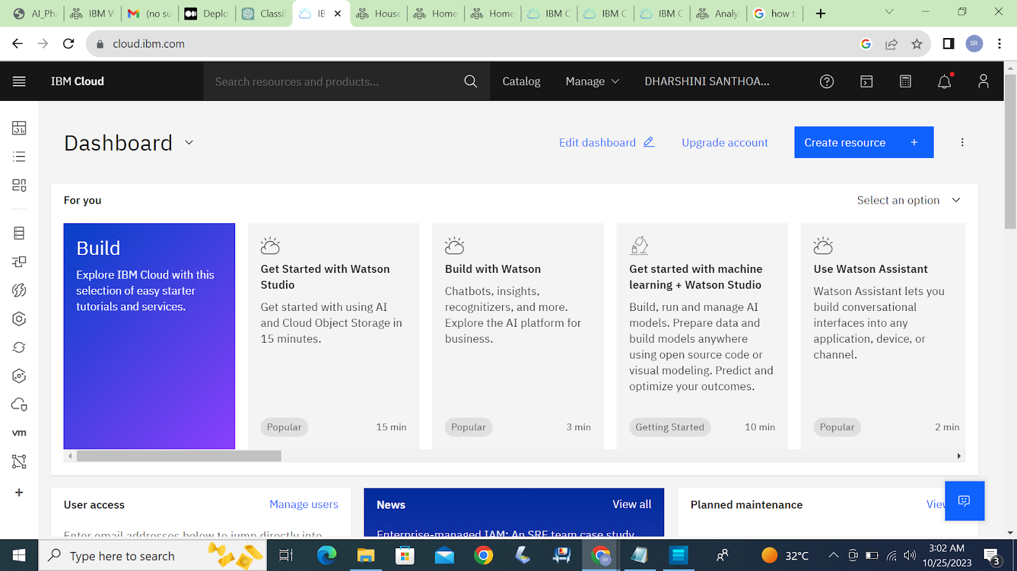

*Step 2: Go to catalog and create a Watson Studio service in the AI category.*

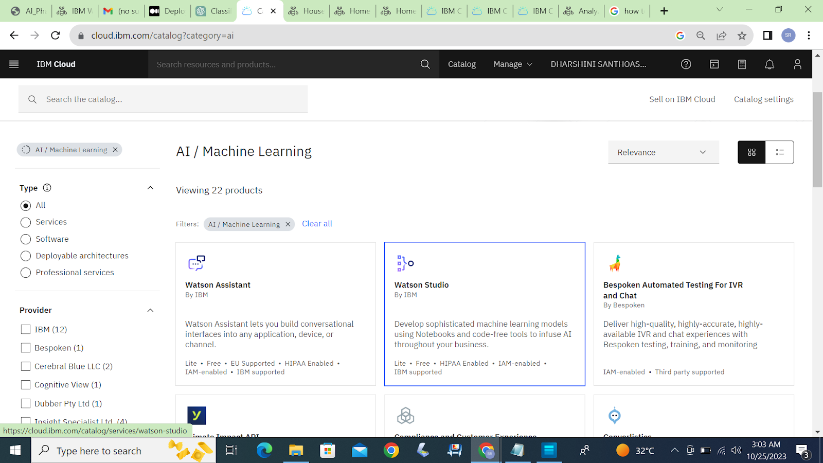

*Step 3: Get started to launch Watson Studio Dashboard.*

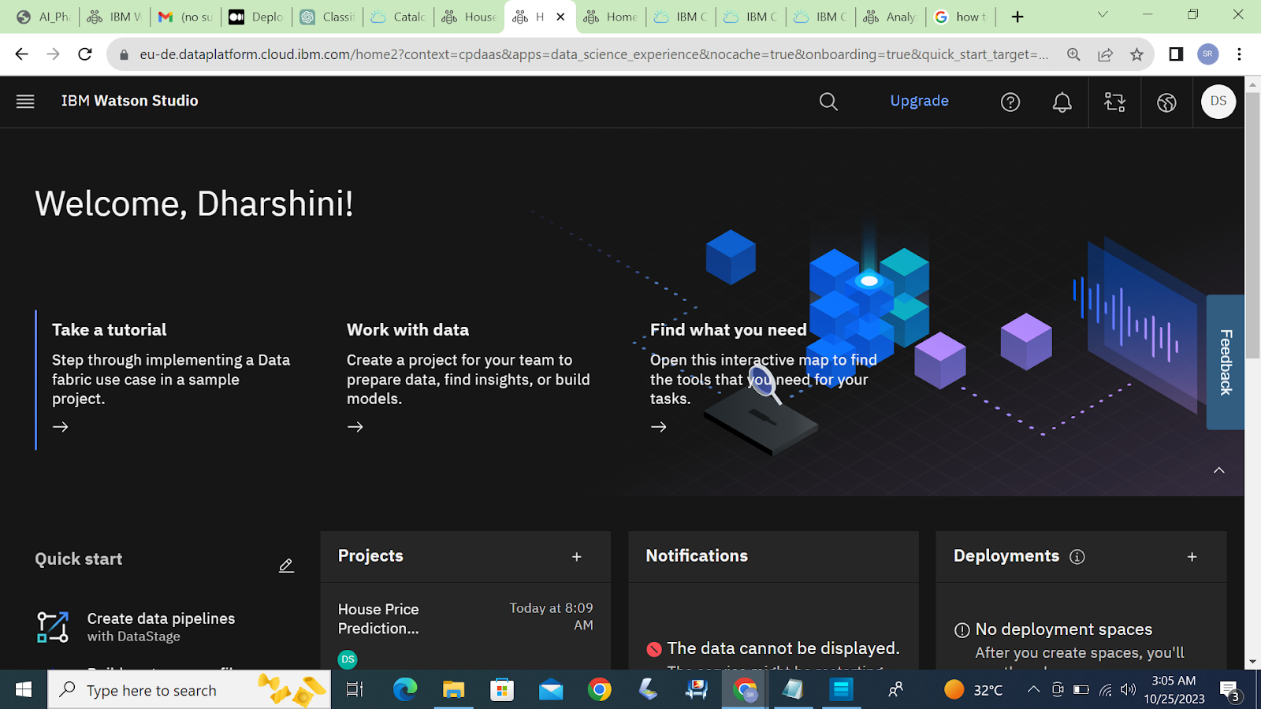

*Step 4: Create a project in IBM Watson Studio in IBM Cloud and assign a Cloud object storage to manage datasets.*

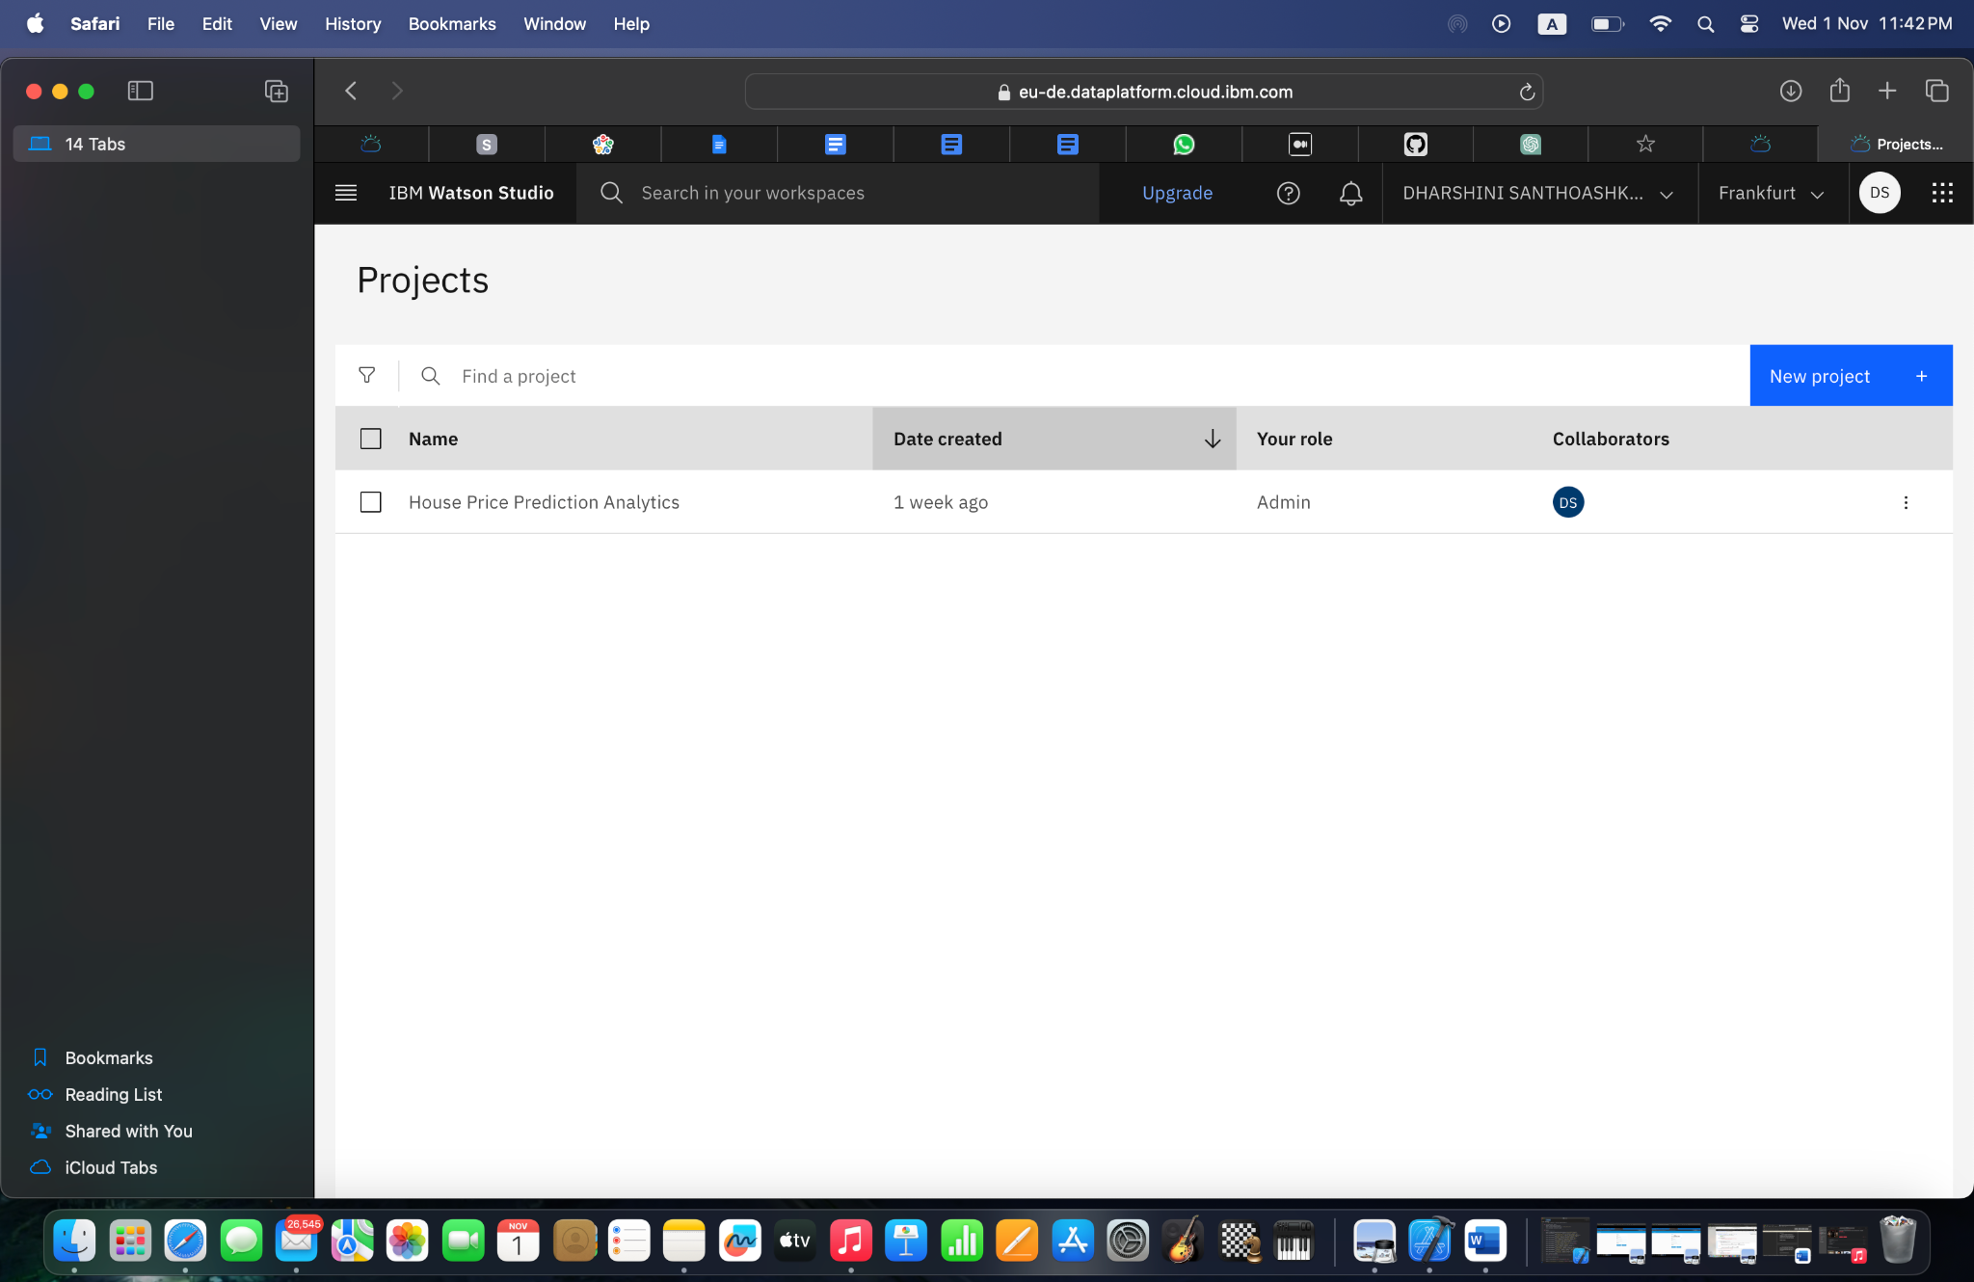

*Step 5: Add a jupyter notebook instance in your project to Develop and Deploy Machine Learning Model.*

1. Import necessary library packages.

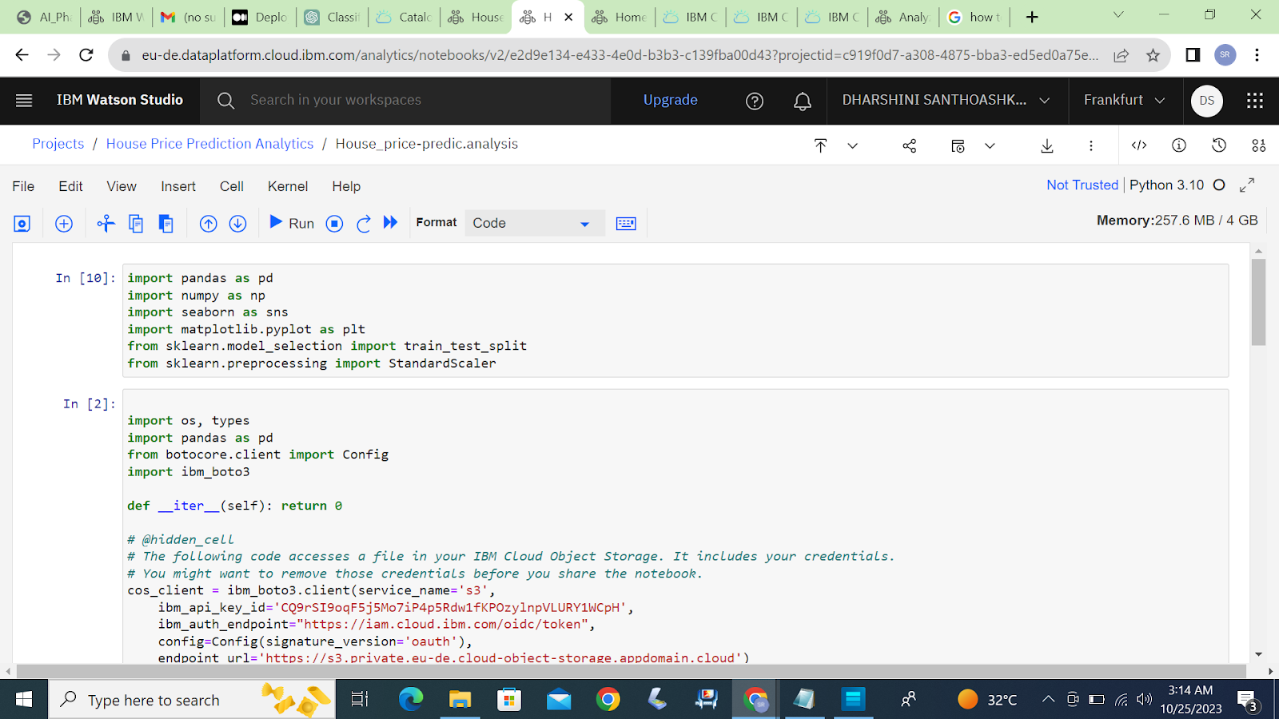

1. Import a dataset and proceed further with pre-processing steps and build the model.

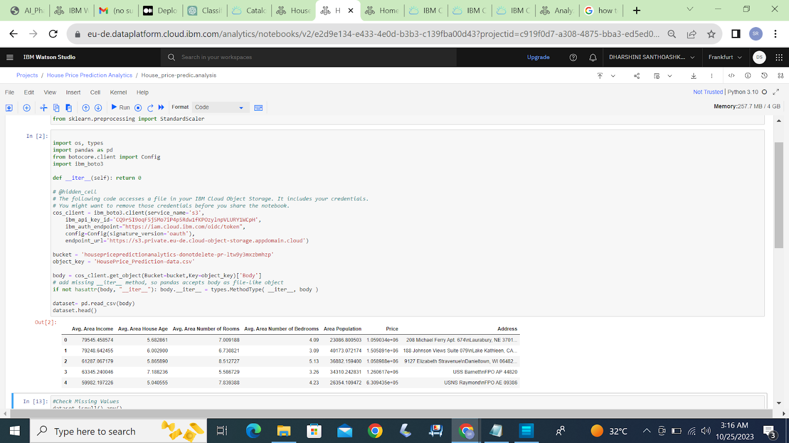

*Step 6: Train the build model and evaluate them.*

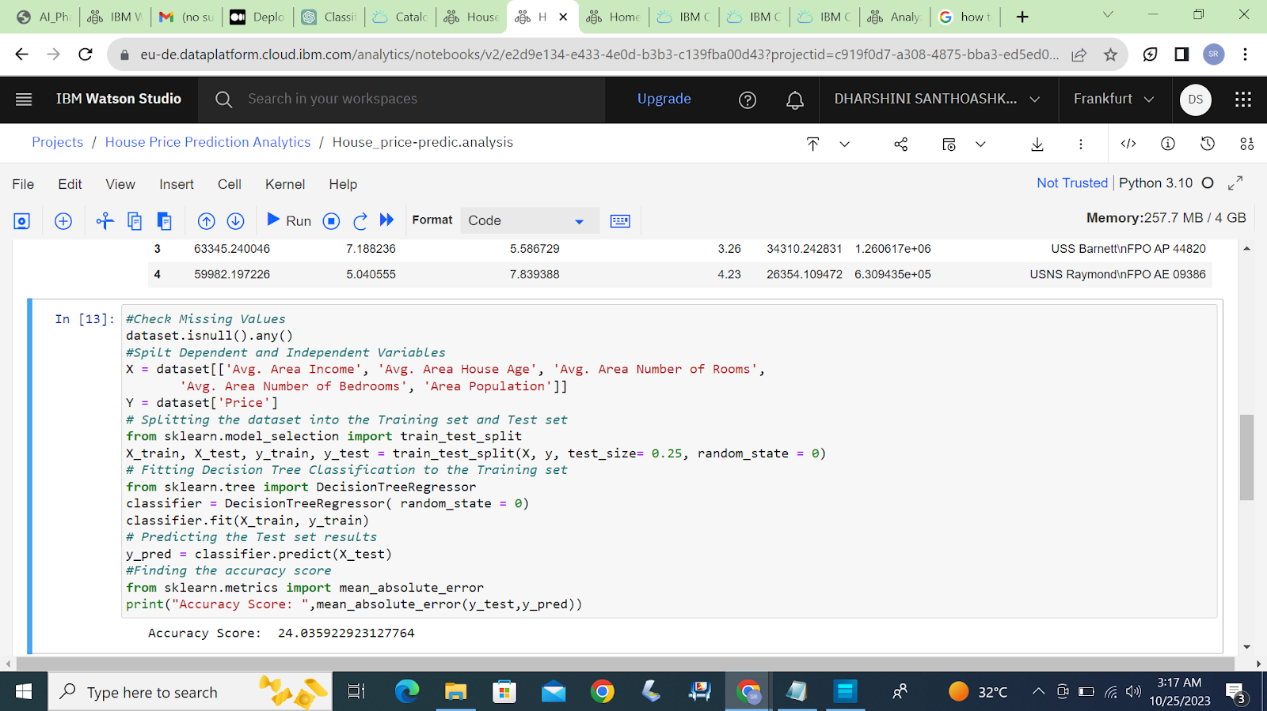

Model was built, trained and tested.

**Import WatsonMachineLearningAPIClient library.**

Once the library is imported, you can use it to interact with the Watson Machine Learning service and work with your deployed models and assets.

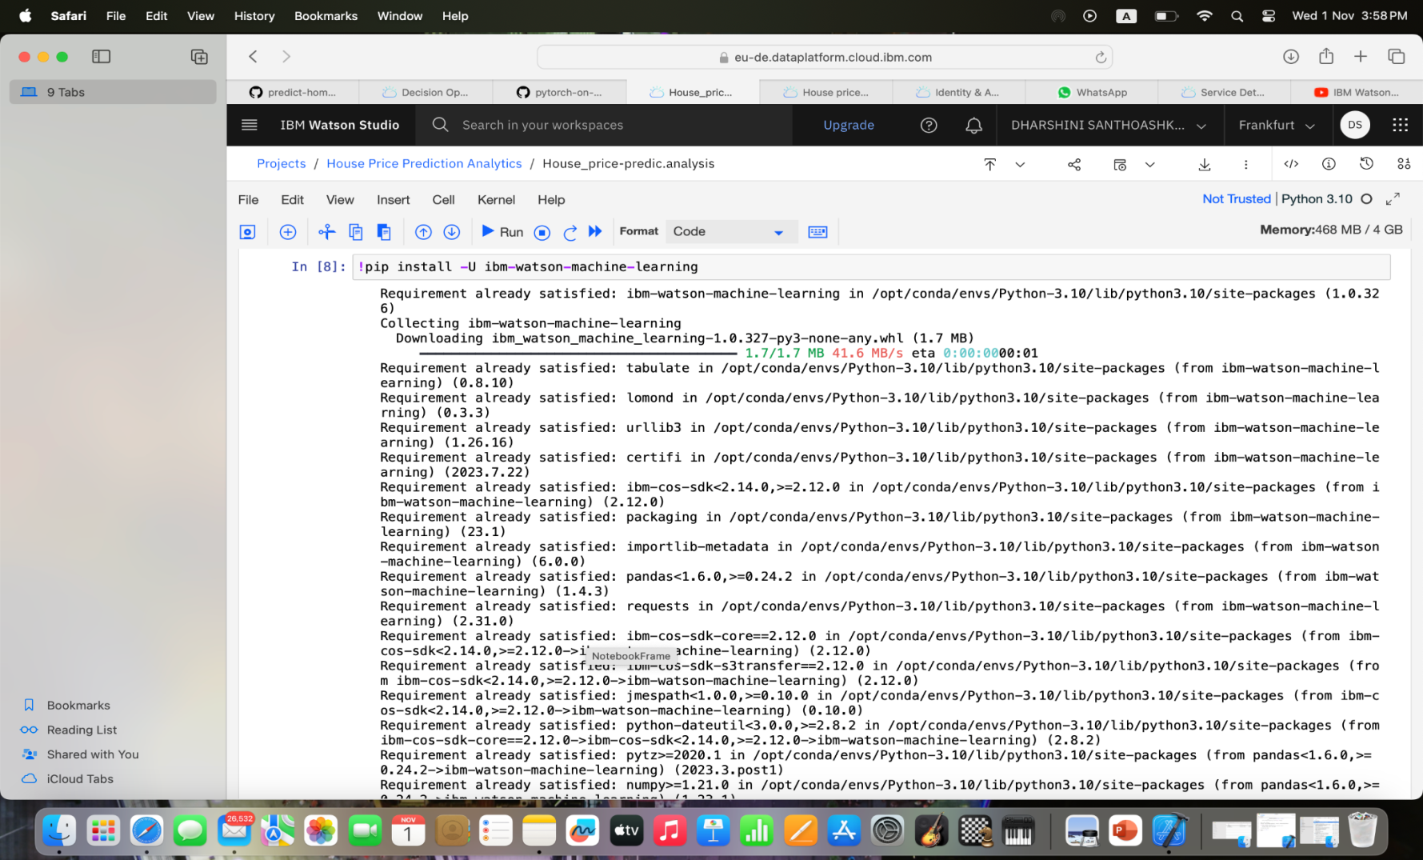

**Initialize the WML API Client.**

Watson studio uses Watson Machine Learning service credentials to access WML service, so paste the credentials.

In this step we have to specify our machine learning model properties and store the model in the WML repository.

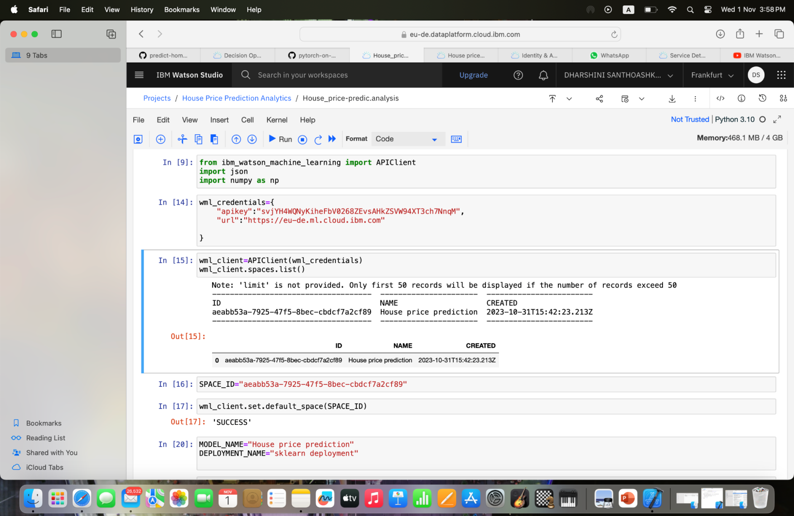

**Machine learning model is deployed.**

Now we are ready to deploy our machine learning model as a Web service.Finally we are done deploying our machine learning model.

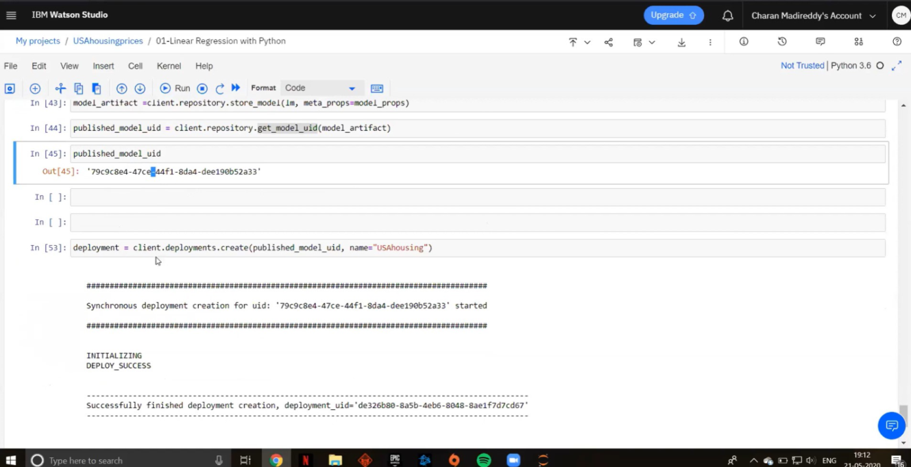

**Web Application for our Machine learning model.**

Our machine learning model was deployed as web service

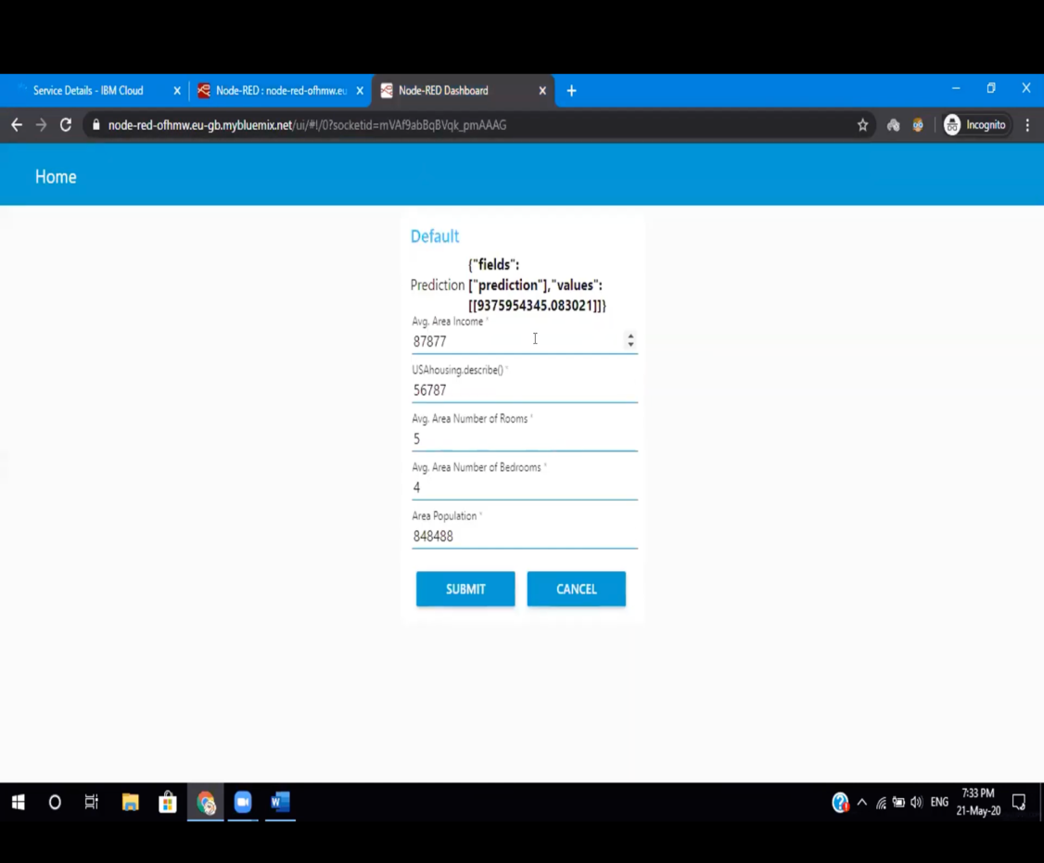

**Conclusion**

Using IBM Cloud Watson Studio, we have learned how to train models to predict outcomes in real-time and deploy them for use in applications. This process helps you optimise resources, reduce risks, and stay ahead . It's about transforming data into action.